

CECA MIDLANDS AWARDS

APPLICATION FORM

LIFETIME ACHIEVEMENT AWARD 2022

midlands AWARDS 2022

The CECA Midlands awards celebrate the best people and projects and the entries should reflect that. This special lifetime achievement award recognises a construction professional who has made an outstanding contribution to the sector.

The candidates will be based on nominations from a senior individual within the organisation. The nominated individual will have consistently made an outstanding contribution to the industry and represents a 'model of excellence' across their entire career.

The entry should have one main proposer but feel free to provide details of other relevant parties. (With written permission if you are providing details).

**Criteria**

Each written application can be accompanied by a photograph/s if relevant and, or other supporting evidence. (Maximum of 1200 words).

The submission must endeavour to meet the following criteria – ideally incorporate these criteria as headings or make them easy to identify:

* Long service within the construction industry
* Evidence of mentoring and leadership
* Continual improvement throughout their career
* Having kept abreast and at the forefront of innovation and industry advancement
* An individual who has embraced fairness and diversity throughout their career
* An outstanding individual who is both liked and respected across the industry



midlands AWARDS 2022

**NOMINATING COMPANY DETAILS**

|  |  |
| --- | --- |
| Company name: | Currall Lewis & Martin (Construction) Ltd |
| Contact name: (author) | Amie Pinfield |
| Contact job title: | Marketing & Business Development Administrator |
| Contact telephone: | 07954312014 |
| Contact email: | amie@clmconstruction.com |

**EMPLOYEE DETAILS**

|  |  |
| --- | --- |
| Employee’s name: | Barrie Cooper |
| Job title: | Project Manager |
| Length of service: | CLM 50 Years, Industry 56 years |
| Contact telephone: | 07976605312 |
| Contact email: | barrie@clmconstruction.com |

**SUBMISSION (below)**

**Long service within the Construction Industry**



Barrie’s lifetime career in the Construction Industry began in the 1960s, when he was employed at his Father-in-laws house building firm. He was introduced to CLM in 1972.

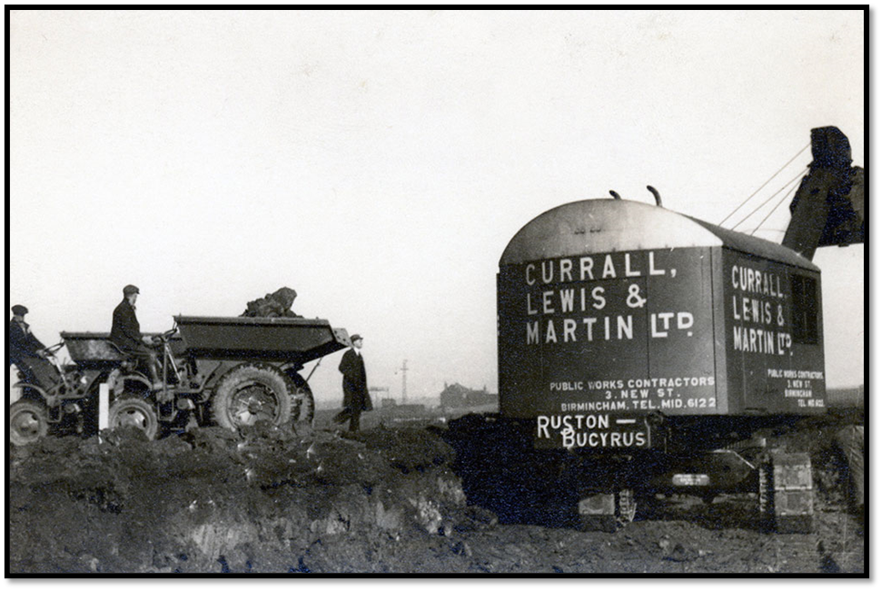

Can you guess which one is Barrie? 

He worked primarily on Canal Reservation projects, protecting local heritage and maintaining canal use.

One of Barrie’s first projects as site manager was at Villa Park, installing executive boxes at the Trinity Stand, renovating the North Stand, providing excellent facilities for fans to enjoy watching the Villa play.

The works were so well received, CLM became the Aston Villa bus sponsor.

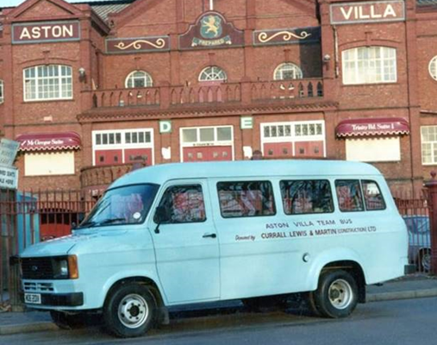

Barrie’s extensive canal experience transferred into river networks.  
In the 1980s, he completed rebuilding works on the River Severn. This made a positive impact to the lives of people who lived along its banks, whilst enabling river traffic.

In the winter of 1985, the Staffordshire James Brindley canal arch-bridge was demolished by the Transport Research Laboratory for Brick Arch structure research.  
Barrie and his team reconstructed the bridge in the winter conditions. This presented technical problems, overcome through innovatively constructing the bridge inside an enclosure; removing the risk the freezing weather presented.   
This reconstruction project was the last arch bridge built in the UK and was an exact replica of the original James Brindley bridge- a legacy to the 18th century engineer.

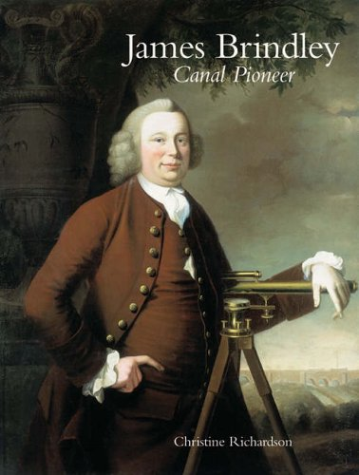

Barrie contributed a lifetime to the maintenance, refurbishment and building of these crucial structures from the 1980’s to present day.

Bridges play a vital role connecting the population across numerous sectors connecting communities, and growing economies.

There are endless examples of Barrie’s bridge projects, but a few that deserve particular mention are:

* Banbury Rail bridge- Coventry
* Building numerous and innovative Warwickshire County bridges
* Building dozens of bridges over the West Midlands, particularly over rivers and canals, such as Pope bridge and Stonestreet Bridge
* Installing the Black Country Museum Swing Bridge- Utilised on the set for Peaky Blinders

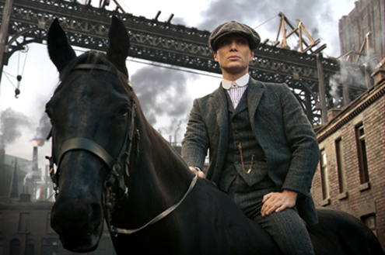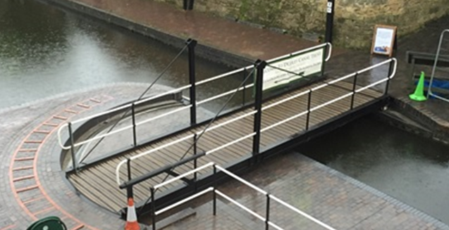

**Black Country Museum Swing Bridge**

Whilst bridges were Barrie’s forte, his capabilities expanded into other areas of civil engineering, including Dam renovation, rail work and castle stonework. He diversified his efforts on a challenging Butlins water park project, providing excellent facilities to thousands of families.

Moving forward in the years, and in context with “connecting communities” through infrastructure, he converted numerous disused rail lines into thriving multiuser paths for client Sustrans.

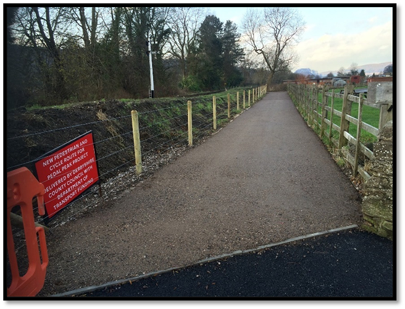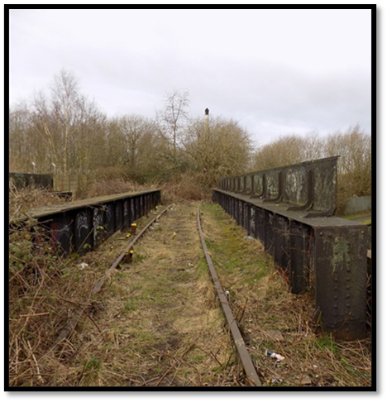

With no signs of slowing, Barrie is still at infrastructures forefront, currently working on HS2, one of the UK’s largest and most complex infrastructure projects.



This started with Environmental mitigation works to key structural investigation works necessary for new tunnel plans.

In true Barrie style, he continues to make an impact. He was the first to pour concrete on HS2, and his most recent accolade is winning LM-JV’s “Best Subcontractor” award.

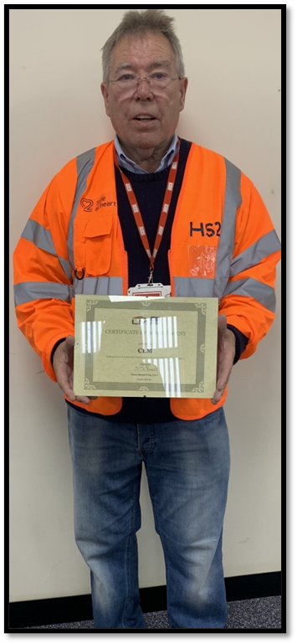

**Evidence of Mentoring and Leadership**

Barrie’s worked with numerous younger people throughout his career, making positive impacts to many.

Ron Pinfield, CLM’s Managing Director, worked under Barrie as an engineer for several years. Barrie acted as a mentor to Ron, helping guide him in his earlier construction days.

Barrie inspired Sandip Patel to continue his learning and finish his BSC degree in Civil Engineering. Sandip has now gone onto continue his career in the construction industry as a senior Quantity Surveyor.

His passion for civil engineering also inspired his son, Scott Cooper, to pursue a career in the sector, and Scott is now a MD for Kier Strategic Highways.

Now in his 70’s, Barrie remains a mentor to the younger generation, such as Brad Gutteridge. Brad is able to learn from Barrie’s priceless industry experience, whilst acting as a reverse mentor regarding the technological side of the current industry.

Outside work, Barrie continued his leadership role as a Youth Leader at a local youth club, and football club manager for many years.

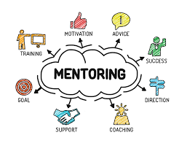

**Continual improvement throughout their career**

Throughout his career, Barrie’s ensured he is at the forefront of industry standards and legislation.

Evidencing his most recent achievement and drive to improve, he received the “What Looks Good,” Best Sub-Contractor Award from HS2/ LM-JV.

He recently became a Professional Member of the Chartered Institution of Highways and Transportation demonstrating his industry commitment.

**Having kept abreast and at the forefront of innovation and industry advancement**

Barrie develops and adapts to a changing industry and has for over five decades, where Health & Safety within the industry has massively improved.

Over his long career, he’s worked on numerous industry advancements, carrying out the first repair scheme, R1, on the Midlands Links, working closely with materials, suppliers and manufacturers to create a suitable concrete from a laboratory under the motorway.   
This has paved the way for Midlands Links repair strategies used today.

Barrie is continually looking for innovative construction methods- utilising pre-fabricated components for culverts and drain repairs and initiating component led construction.

He has pioneered/ sponsored safety innovations, such as introducing a tool attachment to laborers’ belts, eliminating the need to bend down when bricklaying, putting less strain on backs and reducing the risk of Repetitive Strain Injury.



**An individual who has embraced fairness and diversity throughout their career**

Barrie has advocated fairness and diversity throughout his career. He’s passionate about charity work and voluntarily takes part in numerous initiatives. One of these schemes included donating recycled site materials to a local children’s park to be used as recreational equipment.

On previous HS2 projects, he has worked with charities such as Suited for Success, supporting the long term unemployed back into work, and worked with ex-offenders from RMF Group.

This demonstrates his belief in creating an inclusive industry for under-represented groups.



**An outstanding individual who is both liked and respected across the industry**

Barrie’s abilities/ characteristics and a lifetime within the industry has earned him a reputation forged from respect and likeability.   
No matter where he works, or for whichever client, the outcome is the same- completing projects beyond client satisfaction, and building long-lasting customer relationships. This skill enables him to resolve difficult situations that arise during projects, such as collaborating with landowners and farmers to establish site access when the client hasn’t been able to.

Barrie enjoys planning industry and networking events such as Cheltenham and Bescot races, bringing colleagues together on a personal level.

**Summary**

Barrie has achieved a fulfilling, diverse career over 60 years within the industry, contributing to the sector in numerous ways. He’s continually adapted and changed throughout the industry, demonstrated through his impeccable health and safety record, where under his supervision, no-one has had an accident or been seriously injured from 1960-2021.

It is ironic that Barrie has built and reconstructed so many bridges because his career has represented a bridge, spanning multiple decades and linking several eras, giving the younger generation an insight into days gone by.

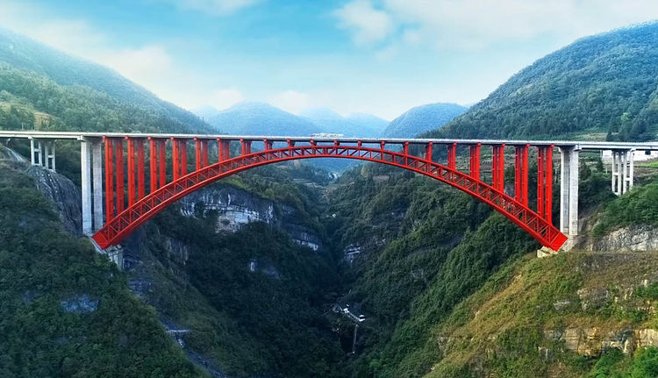

His attainments demonstrate his lifetime dedication to the industry, and the positive impact made in communities. This makes Barrie the obvious candidate for the CECA Lifetime Achievement Award in recognition of his inspiring career.